Year 11 Parents Evening
Tuesday 13th January 2026
Welcome to Year 11 Parents Evening!
We hope you get lots of information out of this evening!
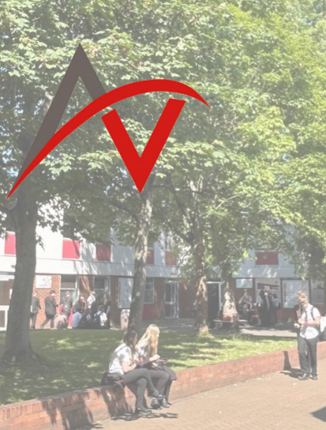
Key Dates
Winter Mock Exams
Mock Exam timetables will be distributed soon by Form Tutors. Upcoming information assembly will be recorded and shared with parents
w/c 2nd February – Spring MOCKS
w/c 9th February – Spring MOCKS
HALF TERM
w/c 23rd February – Spring MOCKS + Mock Speaking Exams
w/c 2nd March – Mock Speaking Exams + Practical Mock Exams
w/c 9th March – Practical Mock Exams
Summer Examination Series
Normal school day throughout this period with all students expected in school. We will run booster sessions throughout this time for upcoming exams
Mid-End of March – Key Assessment 2 Report published
Thursday 26th March – Parent Exam Information Evening
EASTER – There will be lots of revision sessions available in school
w/c 20th and w/c 27th April – Practical Exams in Creative Arts subjects
w/c 4th May – MFL Speaking Exams and FULL SUMMER EXAMS BEGIN
w/c 5th May – FULL SUMMER EXAMS BEGIN
HALF TERM - There will be lots of revision sessions available in school
Monday 15th June – final whole cohort exam
Tuesday 16th June – final Y11 written exam
Wednesday 24th June – National Contingency Day – must be available for this in case of any rearranged examinations
Wednesday 25th - Year 11 Prom

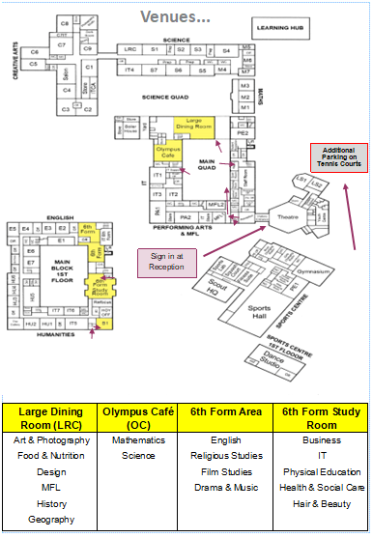



Full suite of online revision guides at your fingertips. Just log in with your Office 365 login
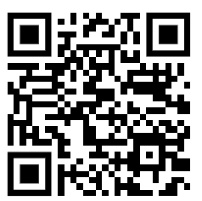

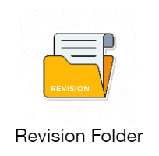
AV Student Shared – REVISION 2026 – Access via “Links” on Edulink
Tailor made revision resources, past papers, guides and much more – collated by your teachers who know you best


Arrow Vale Website – lots of subject specific resources available on “How to Revise” for each of your courses. Lots more to come on this page as we build towards the summer!
We would really value your feedback on our offer here at Arrow Vale. Please take 2-3 minutes to fill in this short survey as you leave the building this evening

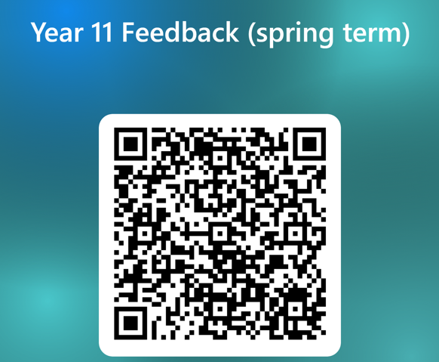

If you need to contact us, here are your key Year 11 staff:
Mr Barratt – Assistant Principal – jbarratt@arrowvale.crst.org.uk
Mrs Smith – Vice Principal – dsmith@arrowvale.crst.org.uk
Mr Butler-Varnall – Year Team Leader – jabutler@arrowvale.crst.org.uk



